Axis of an Oblique Circular Cylinder
# Source: AI Source: Provided by: [Data Path: Persons Table -> ID Column: 1, Name_En Column: Motasem Essam] -> From: [ChatGPT] on [7/25/2026]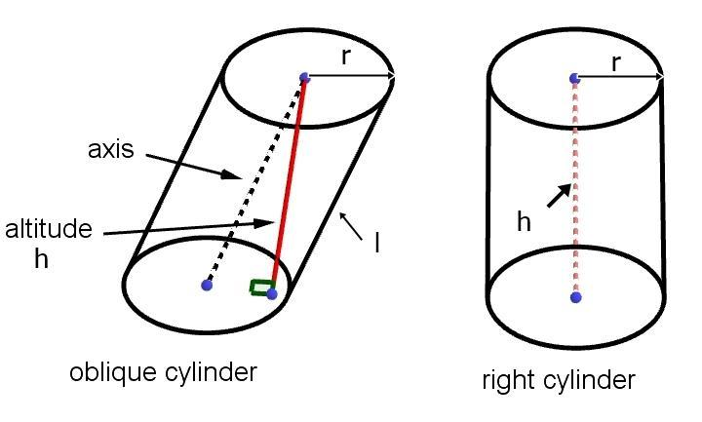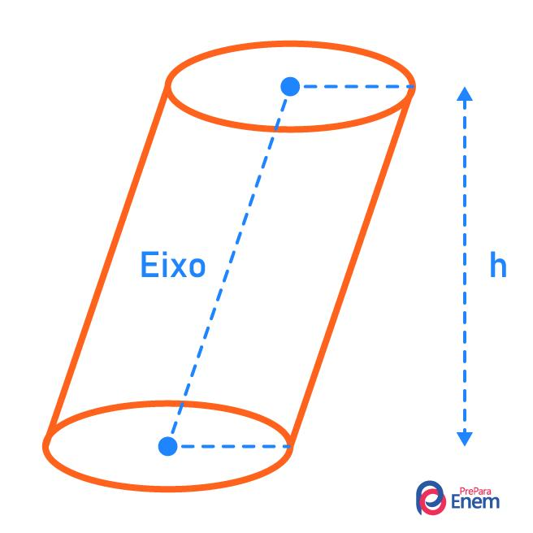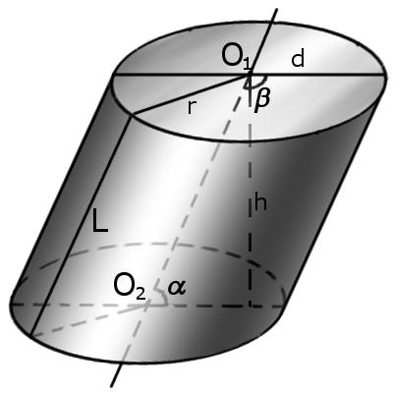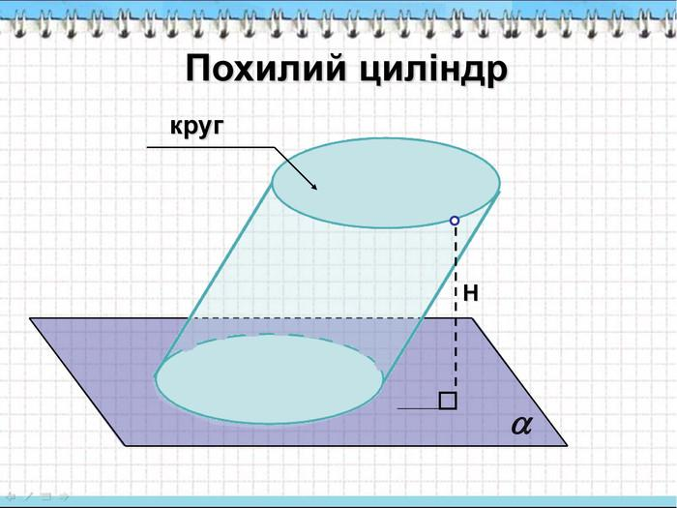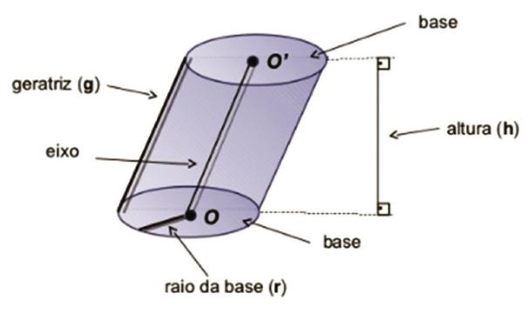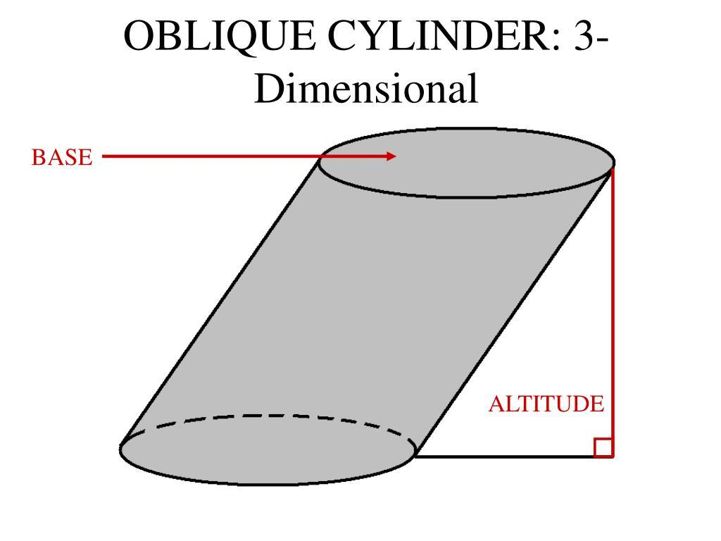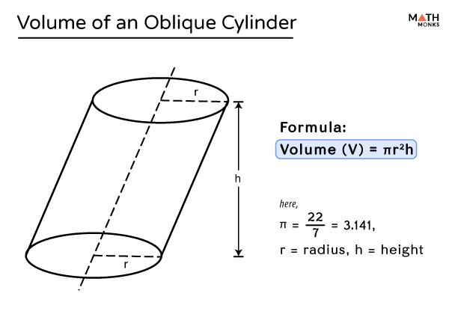

Definition
# Source: AI Source: Provided by: [Data Path: Persons Table -> ID Column: 1, Name_En Column: Motasem Essam] -> From: [ChatGPT] on [7/25/2026]
The axis of an oblique circular cylinder is the straight line passing through the centers of its two parallel, congruent circular bases.
Unlike the axis of a right circular cylinder, the axis of an oblique circular cylinder is inclined to the base planes rather than perpendicular to them.
- Axis: The central line connecting the base centers.
- Direction: Inclined to the base planes.
- Base relationship: The circular bases remain parallel and congruent.
- Axis length: The distance between the centers of the two bases, measured along the inclined axis.
- Perpendicular height: The shortest distance between the two base planes.

Simple Definition
# Source: AI Source: Provided by: [Data Path: Persons Table -> ID Column: 1, Name_En Column: Motasem Essam] -> From: [ChatGPT] on [7/25/2026]
The axis of an oblique circular cylinder is the sloping straight line that passes through the centers of its two circular bases.

Geometric Representation
# Source: AI Source: Provided by: [Data Path: Persons Table -> ID Column: 1, Name_En Column: Motasem Essam] -> From: [ChatGPT] on [7/25/2026]
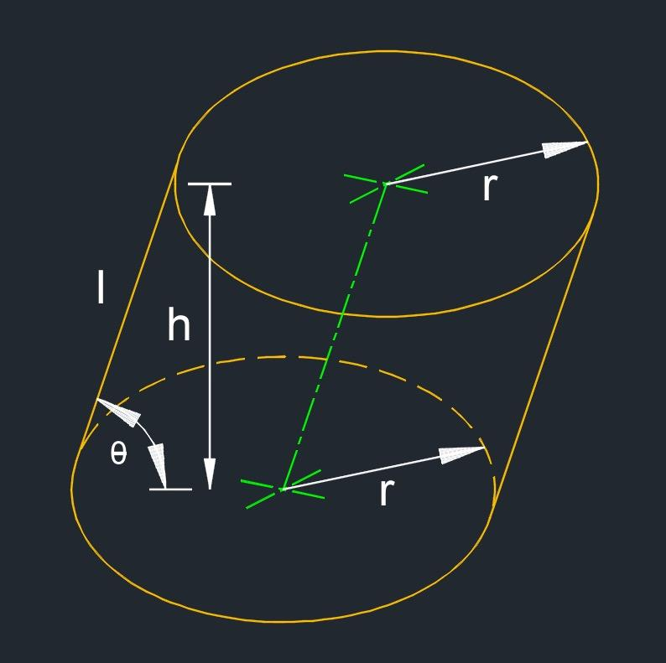
Let $O_{1}$ and $O_{2}$ be the centers of the lower and upper bases.
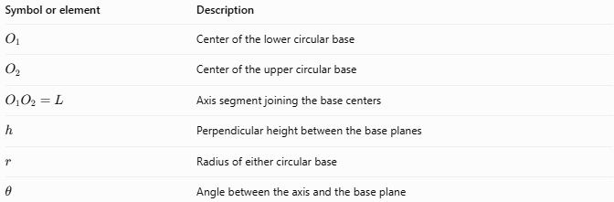
Symbol or element | Description
$$O_{1}$$ | Center of the lower circular base
$$O_{2}$$ | Center of the upper circular base
$$O_{1}O_{2}=L$$ | Axis segment joining the base centers
$$h$$ | Perpendicular height between the base planes
$$r$$ | Radius of either circular base
$$θ$$ | Angle between the axis and the base plane
For a genuinely oblique cylinder, the axis is inclined, so its length $L$ is greater than the perpendicular height $h$.

Main Characteristics of the Axis
# Source: AI Source: Provided by: [Data Path: Persons Table -> ID Column: 1, Name_En Column: Motasem Essam] -> From: [ChatGPT] on [7/25/2026]
- Passes through both base centers: The axis joins the centers of the two circular bases.
- Inclined to the base planes: It is not perpendicular to the bases in a genuinely oblique cylinder.
- Defines the central direction: It describes the direction in which the base centers are displaced.
- Longer than the perpendicular height: The inclined axis length exceeds the perpendicular separation of the base planes.
- Distinct from the lateral edges: The axis passes through the interior, while the lateral edges lie on the curved surface.
- Not a symmetry axis in general: An oblique circular cylinder does not generally have the same rotational symmetry about its inclined axis as a right circular cylinder.

Mathematical Properties and Formulas
# Source: AI Source: Provided by: [Data Path: Persons Table -> ID Column: 1, Name_En Column: Motasem Essam] -> From: [ChatGPT] on [7/25/2026]

Axis length and perpendicular height
# Source: AI Source: Provided by: [Data Path: Persons Table -> ID Column: 1, Name_En Column: Motasem Essam] -> From: [ChatGPT] on [7/25/2026]
If $L$ is the axis length and $θ$ is the angle between the axis and a base plane:
$$\boxed{h=Lsinθ}$$
Therefore:
$$\boxed{L=\frac{h}{sinθ}}$$
These formulas apply when $0^{∘}<θ<{90}^{∘}$.

Using the angle with the perpendicular direction
# Source: AI Source: Provided by: [Data Path: Persons Table -> ID Column: 1, Name_En Column: Motasem Essam] -> From: [ChatGPT] on [7/25/2026]
If $α$ is the angle between the axis and the normal to a base plane:
$$\boxed{h=Lcosα}$$
Since $α={90}^{∘}-θ$, this is equivalent to the preceding formula.

Axis length using coordinates
# Source: AI Source: Provided by: [Data Path: Persons Table -> ID Column: 1, Name_En Column: Motasem Essam] -> From: [ChatGPT] on [7/25/2026]
For base centers $O_{1}=(x_{1},y_{1},z_{1})$ and $O_{2}=(x_{2},y_{2},z_{2})$, the axis length is:
$$\boxed{L=\sqrt{(x_{2}-x_{1})^{2}+(y_{2}-y_{1})^{2}+(z_{2}-z_{1})^{2}}}$$
The perpendicular height is determined by the distance between the parallel base planes, not simply by the axis length.

Volume of an oblique circular cylinder
# Source: AI Source: Provided by: [Data Path: Persons Table -> ID Column: 1, Name_En Column: Motasem Essam] -> From: [ChatGPT] on [7/25/2026]
Although the axis is inclined, the volume formula still uses perpendicular height:
$$V=πr^{2}h$$
Substituting $h=Lsinθ$:
$$\boxed{V=πr^{2}Lsinθ}$$

Worked Examples
# Source: AI Source: Provided by: [Data Path: Persons Table -> ID Column: 1, Name_En Column: Motasem Essam] -> From: [ChatGPT] on [7/25/2026]

Example 1 — Find the axis length
# Source: AI Source: Provided by: [Data Path: Persons Table -> ID Column: 1, Name_En Column: Motasem Essam] -> From: [ChatGPT] on [7/25/2026]
An oblique circular cylinder has a perpendicular height of $6 cm$. Its axis makes an angle of ${30}^{∘}$ with the base plane. Find the axis length.
Solution:
$$L=\frac{h}{sinθ}$$
$$L=\frac{6}{sin{30}^{∘}}=\frac{6}{0.5}$$
$$\boxed{L=12 cm}$$

Example 2 — Find the perpendicular height
# Source: AI Source: Provided by: [Data Path: Persons Table -> ID Column: 1, Name_En Column: Motasem Essam] -> From: [ChatGPT] on [7/25/2026]
The axis of an oblique circular cylinder is $10 m$ long and makes an angle of ${60}^{∘}$ with the base plane. Find its perpendicular height.
Solution:
$$h=Lsinθ$$
$$h=10sin{60}^{∘}=10(\frac{\sqrt{3}}{2})$$
$$\boxed{h=5\sqrt{3} m≈8.66 m}$$

Example 3 — Find the axis length from coordinates
# Source: AI Source: Provided by: [Data Path: Persons Table -> ID Column: 1, Name_En Column: Motasem Essam] -> From: [ChatGPT] on [7/25/2026]
The centers of the two bases are $O_{1}=(1,2,0)$ and $O_{2}=(5,2,3)$. Find the axis length.
Solution:
$$L=\sqrt{(5-1)^{2}+(2-2)^{2}+(3-0)^{2}}$$
$$L=\sqrt{16+0+9}$$
$$\boxed{L=5 units}$$

Comparison with Related Concepts
# Source: AI Source: Provided by: [Data Path: Persons Table -> ID Column: 1, Name_En Column: Motasem Essam] -> From: [ChatGPT] on [7/25/2026]
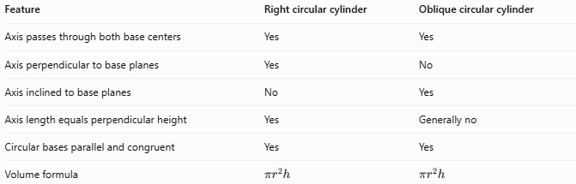
Feature | Right circular cylinder | Oblique circular cylinder
Axis passes through both base centers | Yes | Yes
Axis perpendicular to base planes | Yes | No
Axis inclined to base planes | No | Yes
Axis length equals perpendicular height | Yes | Generally no
Circular bases parallel and congruent | Yes | Yes
Volume formula | $$πr^{2}h$$ | $$πr^{2}h$$
Important distinction: The axis is not the same as the perpendicular height. In an oblique cylinder, the axis follows the inclined direction between the base centers, while the height measures the perpendicular distance between the base planes.

Applications
# Source: AI Source: Provided by: [Data Path: Persons Table -> ID Column: 1, Name_En Column: Motasem Essam] -> From: [ChatGPT] on [7/25/2026]
The axis of an oblique circular cylinder is useful for:
- Describing inclined pipes and cylindrical components.
- Determining the direction and length between the centers of parallel circular ends.
- Calculating perpendicular height from an inclined length and angle.
- Establishing coordinate models for oblique solids.
- Solving volume and geometric-position problems involving inclined cylinders.

Key Points
# Source: AI Source: Provided by: [Data Path: Persons Table -> ID Column: 1, Name_En Column: Motasem Essam] -> From: [ChatGPT] on [7/25/2026]
- The axis passes through the centers of both circular bases.
- It is inclined to the base planes.
- Its length is generally greater than the perpendicular height.
- If $θ$ is the angle between the axis and the base plane, then $h=Lsinθ$.
- The volume formula uses perpendicular height, not axis length directly.
- Both right and oblique circular cylinders have an axis through their base centers.

Conclusion
# Source: AI Source: Provided by: [Data Path: Persons Table -> ID Column: 1, Name_En Column: Motasem Essam] -> From: [ChatGPT] on [7/25/2026]
The axis of an oblique circular cylinder is the inclined central line joining the centers of its two circular bases. Its length differs from the perpendicular height, making it important to distinguish these measurements when solving geometric problems.

